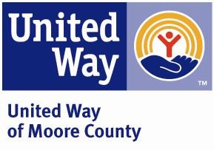

ANTI TERRORISM COMPLIANCE MEASURES

In compliance with the USA PATRIOT Act and other counterterrorism laws, the United Way of Moore County requires that each agency certify the following:

“I hereby certify on behalf of _____________________________________________
(name of grant applicant)
do certify that all United Way funds and donations will be used in compliance with all applicable anti-terrorist financing and asset control laws, statutes and executive orders.”

Print Name: ___________________________________________

Title: _________________________________________________

Signature: ____________________________________________

Date: ________________________________

